1. Please install Flutter SDK, Android Studio/Emulator.

URL:- https://flutter.dev/docs/get-started/install/windows

1. Download the code from Github.

Github URL:- https://github.com/Jijogeorge69/Film-Genres.git

1. Open constants.dart update your IP address. Please don’t add http:// at the beginning.

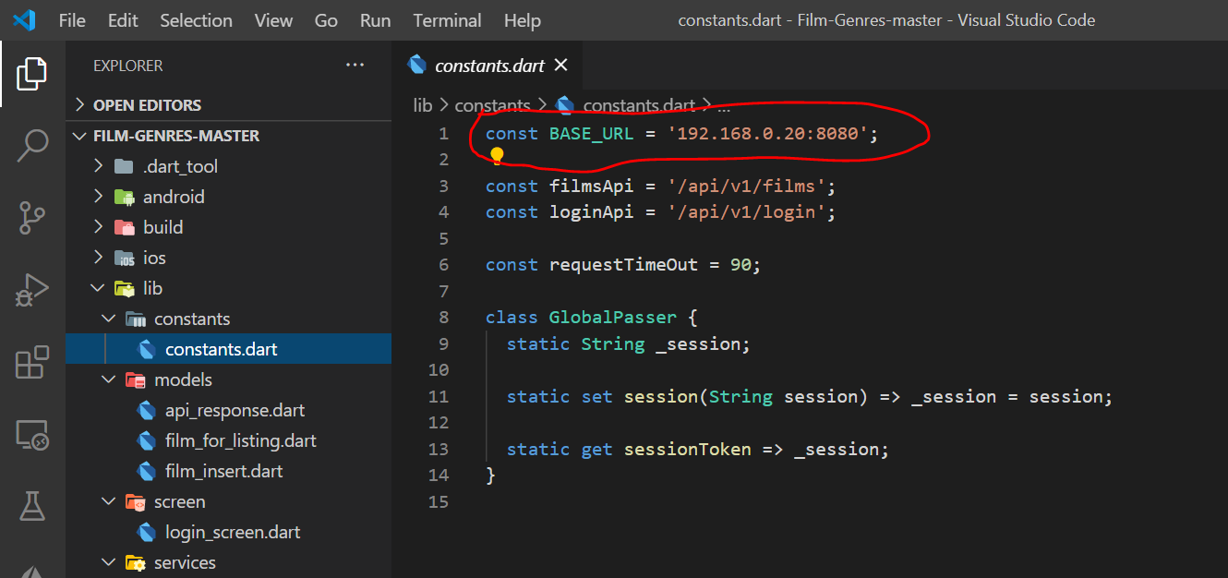

1. Open film_service.dart update the url.

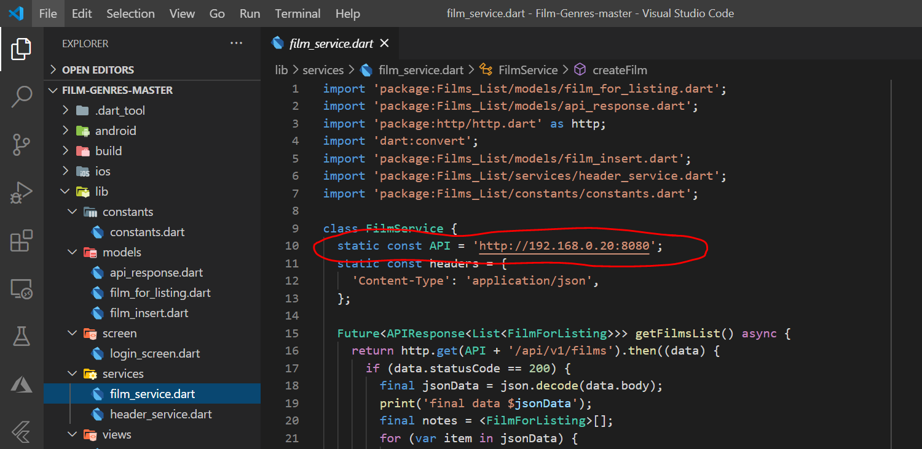

1. Now you can either run the code base on Android studio or VS code.
2. For Android Studio run main.dart.
3. For VS code open terminal type command flutter run. Please start your android studio emulator before hitting flutter run command.

